CS 255 System Design Document Template

UML Diagrams

UML Use Case Diagram
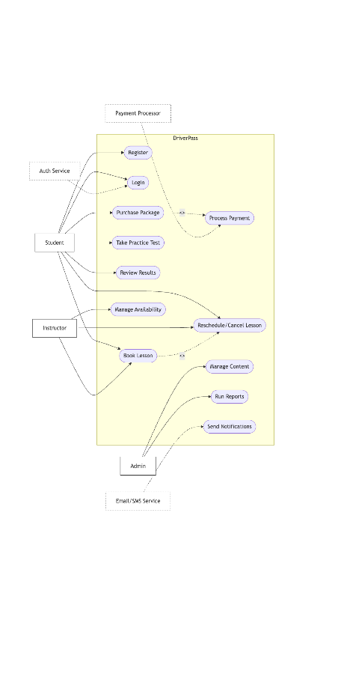

UML Activity Diagrams
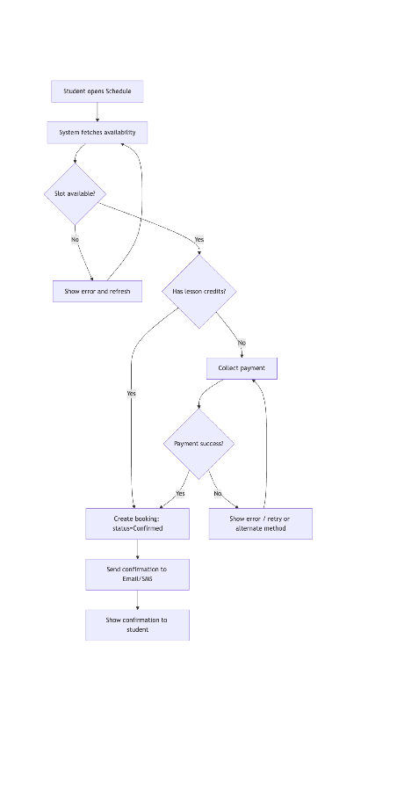
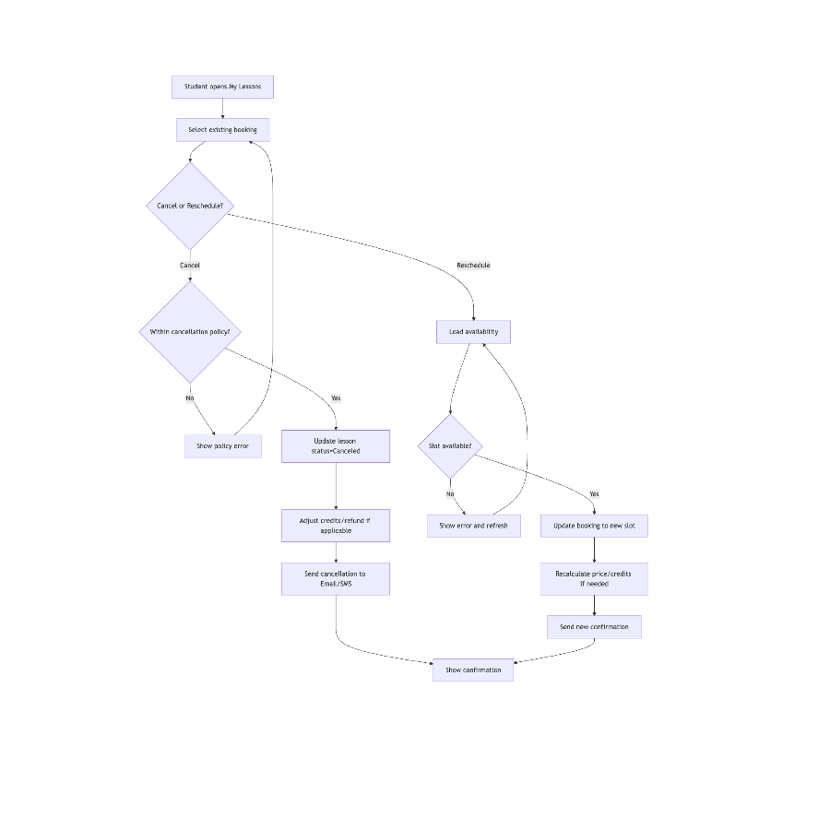

UML Sequence Diagram
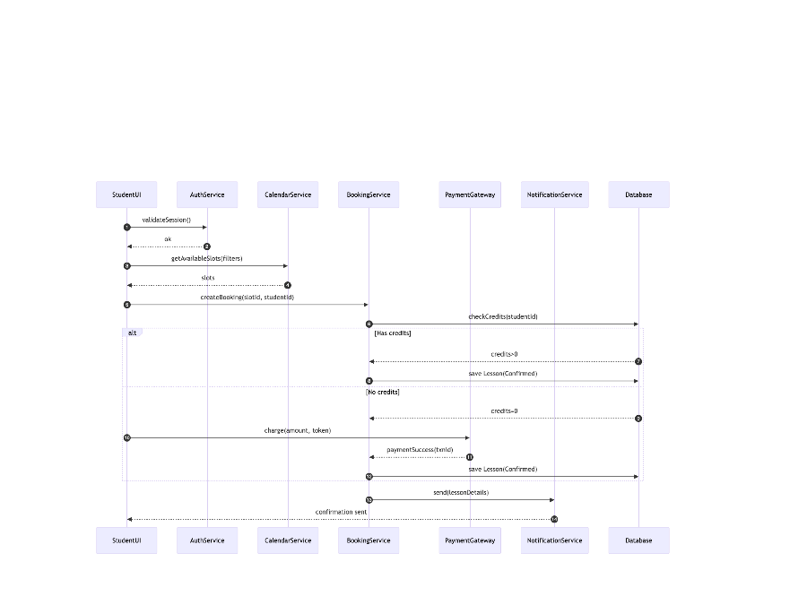

UML Class Diagram
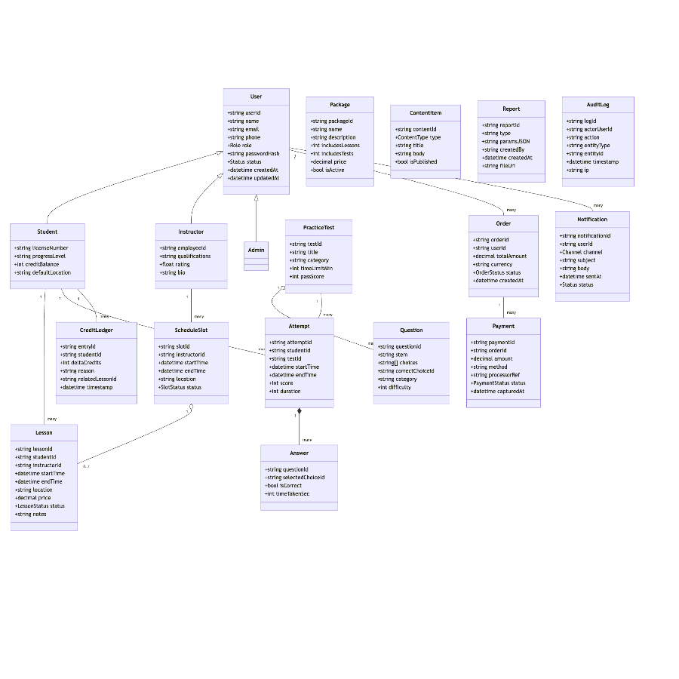

Technical Requirements
DriverPass will be a website that works on phones and on computers, hosted in a trusted cloud so it’s available anywhere. Behind the site there’s a simple app server and a database that stores users, lessons, tests, and results. Payments are handled by a trusted payment company, so DriverPass never stores card numbers. Texts and emails are sent through standard providers. Files like reports live in cloud storage. We start small and can add more as more students join.

For tools and operations, we use Lucidchart for diagrams, GitHub for code, and an automatic process that tests and publishes changes to a test site before going live. We watch the system with basic dashboards and alerts, run daily backups, and can restore data if needed. Security includes HTTPS on every page, secure sign-in, and clear roles with sensitive settings kept in a secure vault. We follow common accessibility guidelines so pages work with keyboards and screen readers, and we design for quick load times so booking and practice tests feel fast.

